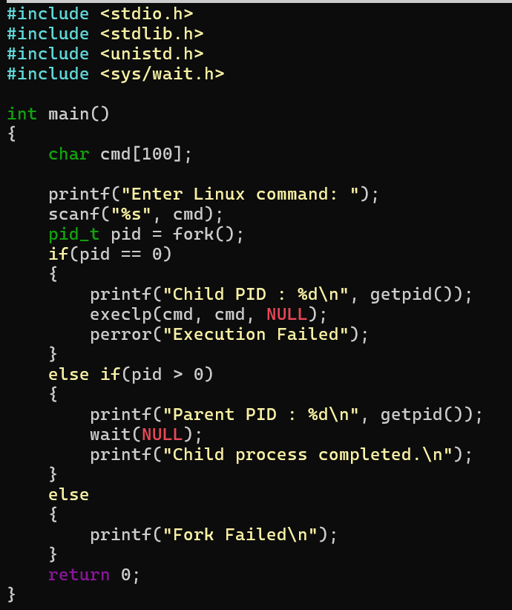

Try uname, lscpu, lsblk, ps, top commands after this program

2. copying the contents from one file to another file

